**Lab 2 Docker Setup**

Now that you are familiar with Docker, it’s time to install it on your Mac.

Docker for MAC: <https://docs.docker.com/docker-for-mac/install/>

Here is a helpful video on installation: <https://youtu.be/mbSsh40_8WM>

After installation follow the instructions below:

1. Docker Desktop
   1. Now when you turn on the computer it should start up docker and virtualization
   2. Click on the Docker Desktop icon
   3. Now you are in an app to help you interact with Docker
      1. A command line, windows power shell, will show up on the right side of the app (if the command line doesn’t show up you will need to go into the search to bring up the terminal or command line.)

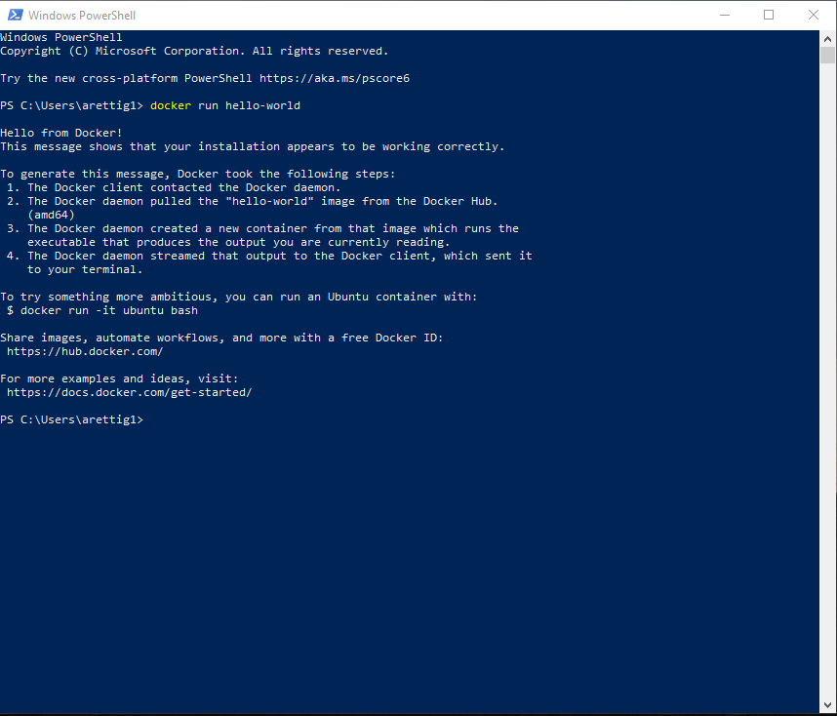

* + 1. We can use the command line to easily interact with docker as well as clicking around the app
    2. Enter the following command in the commandline/terminal “docker run hello-world”
       1. If everything is installed correctly, this command will run your first container with no errors
    3. Now look in the app to find the image it downloaded for hello-world and the container it created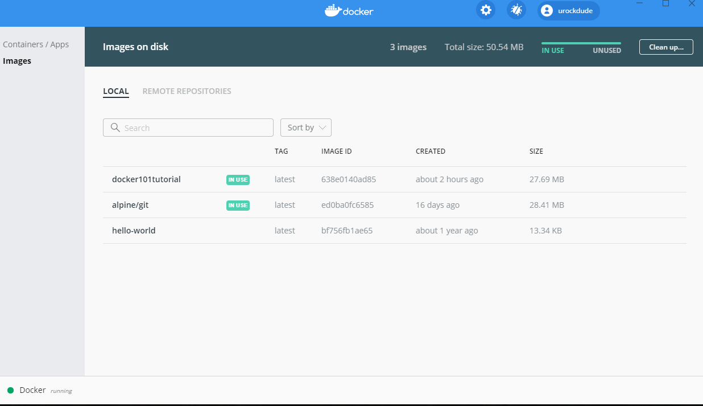

1. Docker Tutorial
   1. Now you can go ahead and do the tutorial if you want. (this part is optional)
   2. Do steps 1-3 to setup a webserver locally with a tutorial
      1. Step 4 is for uploading and can be skipped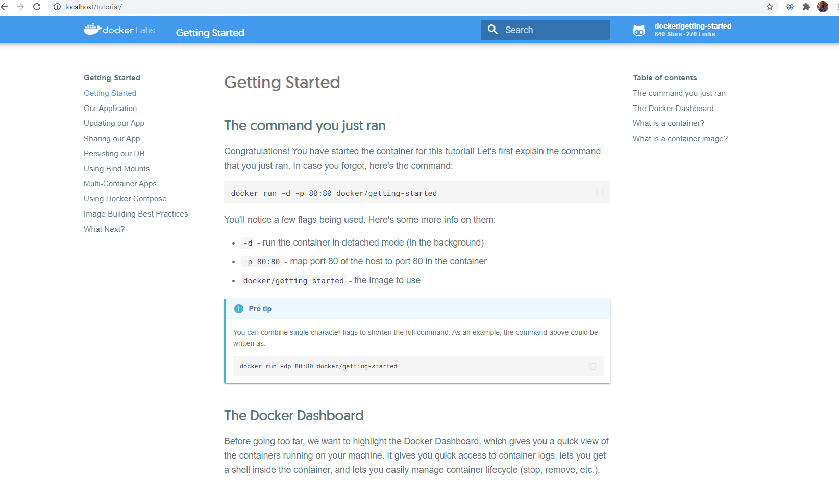
2. **Once you have docker installed just run the command “docker info” in command line and take a screenshot with your desktop in the background as well.**